Low Level Design
Trailer Towing Assistance System

Professor Schafer
December 4, 2007

John Strong
Jon Stembel
Jason Stoller
Brian Fischer
Fernando Contreras

Table of Contents
Introduction 3
Problem Statement 3
Proposed Solution 3
System Description and Block Diagram 4
System Requirements 5
Subsystem Requirements 5
Future Enhancement Requirements 9
Low Level Design 10
Preliminary Bill of Materials 25
Conclusion 25
References 25

Introduction
In this project we seek to design and construct a trailer monitoring system that will provide the operator with useful safety related information about the trailer and its surroundings.

Problem Statement
The purpose of this system is to mitigate a number of safety risks associated with towing a trailer as well as to provide some convenient features for the operator. First, when a vehicle is towing a trailer its blind spots are significantly increased. As a result, normal driving maneuvers, such as changing lanes, become much more difficult and risky. Secondly, any situation that requires the operator to back up can prove hazardous because the operator has a large blind spot directly behind the trailer. If these blind spots could be eliminated or reduced, the safety risks associated with towing a trailer would also be reduced.
Other safety concerns when towing a trailer include the status of the trailer door as well as the temperature inside and outside of the trailer. For obvious reasons, it is important that an operator does not drive away with the trailer doors open. The temperature inside the trailer would be useful when carrying cargo, such as crayons or candle wax, which could be damaged by extreme temperatures. An outdoor temperature measurement would allow the driver to adjust for icy conditions.
Finally, a trailer operator does not currently have an indicator to show if the trailer brake lights and turn signals are working properly. Checking for burnt out bulbs must be done manually. Our goal is to minimize these safety risks by providing more information to the driver.

Proposed Solution
To help reduce the risk associated with these blind spots we propose to build a unified system of sensors to provide the operator with information about potentially hazardous conditions. The sensors will provide information to help mitigate the risks discussed in the Problem Description above. The system will check the trailer’s blind spots for the presence of other vehicles, monitor the status of the trailer doors, measure inside and outside temperatures, monitor the brake & blinker lights, and help avoid collisions when backing up. In essence the system is a unified set of sensors which we will integrate together.
The operator of the trailer will receive this information via a wireless console kept in the cab of the towing vehicle. This console must not only display information, but must at times get the driver’s attention to alert him of unsafe conditions. Additionally, it may be convenient to provide the operator with the option to turn certain features on or off using this wireless console.

System Description and Block Diagram
Figure 1: Block Diagram

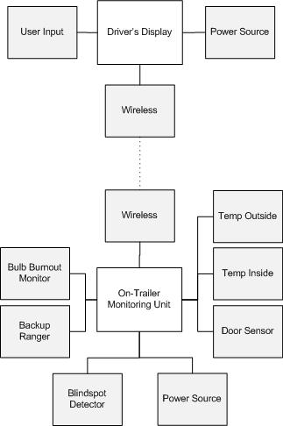
The entire system will consist of two main units along with multiple external sensors. The first main unit will reside on the trailer, and will interface with all of the sensors placed on the trailer. This unit will gather the information from the sensors and then wirelessly transmit this data to the second main unit, the driver’s display.
The driver’s display will reside inside the cab of the towing vehicle. It will be the device through which the operator interfaces with the system. Not only will the driver’s display passively relay information, but it must at times actively get the operator’s attention and alert him of dangerous conditions. The driver will also be able to change certain settings and turn certain features on and off using this display.

System Requirements
Overall System
- Clear, safe, intuitive relay of information to driver
- Appropriate alerts and alarms when necessary
- Easily operated and interfaced with
- Functions in all weather conditions
- Continuous operation
- Specific Features
  - Detect and indicate when car/truck/motorcycle is adjacent to trailer, and on which side
  - Detect and indicate temperature inside trailer
  - Detect and indicate temperature outside trailer
  - Detect and indicate status of trailer door (open/closed)
  - Assist in backing up trailer by providing backup ranging
  - Detect and indicate when (and which) brake/blinker lights are on

Subsystem Requirements
Driver’s Display
- Must display all sensor information
- Must receive user inputs
- Must alert driver of alarmed states when necessary
  - Audible and/or visual
- Wirelessly Communicate with On-trailer unit
  - Two-way communication, send and receive information
- Display information clearly
  - In sunlight
  - At night
- Interface with Driver easily and safely
  - Large buttons, text, indicators
- Sufficiently powered for continuous use

On-Trailer Monitoring Unit
The on-trailer monitoring unit will function as the control center for the system.
- Must connect to all the required sensors
- Must be able to handle short power losses (bad connection from truck to trailer)
- Must include ‘industry standard’ connections for both the trailer and the truck
- Must contain short range wireless communication
- Allow for plug and play connections for all peripherals
- Have a master on/off switch accessible to user
- Operate in all weather conditions (Excluding hurricanes, white-out conditions, etc.)
- Have a sufficient sampling rate to keep user up to date in real time
- Easily installed
- Fail-safe mode; trailer operates normally despite unit failure
- Provide accurate information to the display unit
Wireless Communications
- Reliable communication between on- trailer system and display up to 30 feet
- Reliable communication in all weather conditions
- Sufficiently low power to prevent RF pollution or interference with surrounding devices
- Low power to extend life of power source
- Low data rate to minimize system cost and complexity; high data rate not needed
- Signal must be able to penetrate through body of trailer and truck
- Relatively easy implementation of technology and software
- Transceiver chips must be sufficiently affordable to fit in budget
- Transceiver chip must fit size constraints of system

Blind Spot Detection
- Ambient sunlight (or headlights) should not affect functionality.
- Extreme temperatures should not affect operation.
- The device should withstand rain and snow.
- The sensor’s range should be at least 15ft. The width of a highway lane is 12ft.
- The apparatus should be directional; it should not detect objects that are located behind or in front of the trailer.
- The sensor must return correct readings even if the trailer is moving at fast speeds (80 mph max.)
- A sufficient number of sensors should be placed such that the entire blind spot region is covered.
  - The number of required sensors will depend on the trailer’s length, as well as on the smallest vehicle that should be detected.
  - The maximum trailer length supported by our design will be 15 ft, and the smallest detectable vehicle should be a motorcycle (about 5 ft long). Therefore, a minimum of three sensors will be required for each side.
- Interface with microcontroller should be simple.
- Software implementation should be simple.
- The color/nature of the detected vehicles should not affect accuracy.
- The material of the trailer should not affect operation.
- Accuracy is not paramount; the system must simply decide whether the lanes are empty or not.
- Low power
- Low cost
Backup Ranging
- Operable over a useful distance: 4-6 ft
- Accurate to ±3 in
- Durable
  - Withstand normal driving conditions
  - Withstand effects of weather
- Operable in all weather conditions (excluding white-outs, hurricanes, etc.)
- Color or reflective nature of the object behind trailer should not affect distance measurement
- User can turn off when not in use
- The sensor should easily interface with the microcontroller
- Inexpensive
- Easy to install
- Low Power

Brake/Blinker Light Burn-out Detection
- Detect when a brake light or turn signal bulb has burned out or failed
  - Measure current to bulbs, approximately 2-3A
- Give the operator information about which light is not on
Inside Temperature Monitoring
- Operational over range of -10°F to 110°F
- Accurate to ±3°F within above range
- Sample at least once every 5 minutes
- User can set a ‘safe temp range’; alarm sounds if temperature goes outside the set range
- Low power
- Low cost
Outside Temperature Monitoring
- Operational over range of -10°F to 110°F
- Accurate to ±3°F within above range
- Sample at least once every 5 minutes
- Turn on ‘icy roads’ icon when below 35°F
- Low power
- Low cost
Door Monitoring
- Operational over range of -10°F to 110°F
- Sample at least once every 2 seconds
- Door Open alarm
  - User can turn feature on/off
- Robust – not going to break after repeated slamming of door
- Reliable – gives accurate door open/closed information
  - ‘Door open’ event occurs when doors are completely misaligned
  - ‘Door open’ event DOES NOT occur when door is jostled, vibrated during travel
- Low power
- Low cost

Future Enhancement Requirements
Since our system is aimed at providing the driver with relevant safety information, there are some features that could be added to future revisions of the device which are beyond the current scope of our project.
Load Balance Sensing
In any closed trailer the ability to detect a shift in the load would provide the operator with valuable information. This information would be useful both while towing the load and during the loading/unloading process. While towing a trailer, a shift in the load could affect the behavior of the trailer and cause it to become unsafe. During the loading process this improvement could help the operator load the trailer evenly. Finally, being able to detect a shift in the load could warn the operator in the event that the load has shifted and is resting against the door of the trailer.
Complete Wireless Coupling
Being able to simply attach the trailer to the hitch and drive away without worrying about connecting any wires would simplify things for the operator. Ideally this revision to our system would allow the trailer system to sense the truck and power up and would then power down when the truck is detached from the trailer.

Low Level Design
Driver’s Display
The driver’s display wirelessly communicates with the on-trailer unit and displays the current status of all sensors in an easily-readable and intuitive fashion. The unit provides both visual and audible feedback to the driver and will accept user input. The layout of the display unit is below:
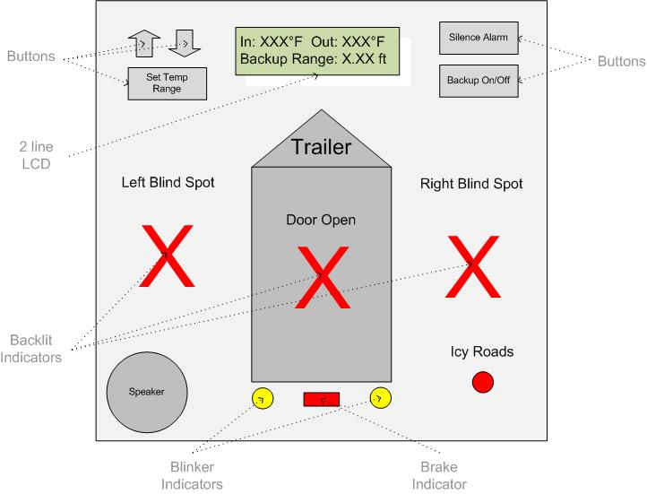

A full schematic diagram of the display unit is in Appendix A.

Two software functions specific to the display unit are 1) Set Inside Temperature Range and 2) Silence Alarm. Both of these functions require input from the user and are outlined in flowcharts below:
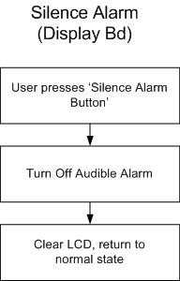
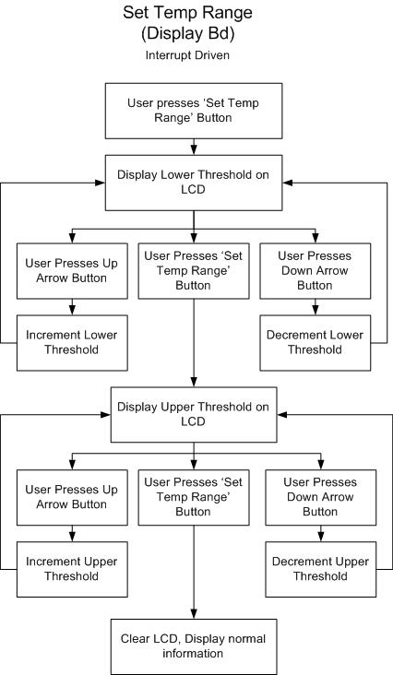

On-Trailer Monitoring Unit
The On-Trailer monitoring unit interfaces with all sensors, interprets their outputs and sends information to the display unit. This unit is responsible for all of the information gathering, a large part of the processing and then relaying the important information to the display unit. Some functions, such as the backup ranging, will be turned on or off using the display board. A complete schematic of the on-trailer monitoring unit is located in Appendix B. Each of the major functions of the on-trailer monitoring unit is discussed below:
Wireless Communications
We chose to use the Zigbee module made by Maxstream. This part communicates with the microcontroller using a standard UART interface. We explored using this interface in previous tasks and should be fairly easy to implement in software. For hardware, the UART interface only requires two data lines. The TX pin on the microcontroller is connected to the DIN on the Zigbee chip and the RX pin on the microcontroller is connected to DOUT on the Zigbee chip. Power and ground are also provided to the Zigbee chip and certain important I/O pins were connected to I/O pins on the microcontroller to allow for flexibility in programming.
Partial Schematic: Wireless Chip
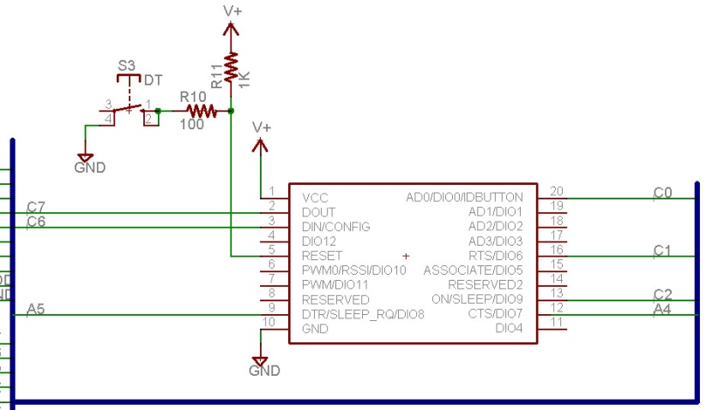

The wireless communication system (zigbee) needs to be able to communicate without interruption for extended periods of time. Communication between both boards should be tested by manually by sending a simple string of characters over a distance of 50ft. and displaying them on the LCD screen. This should be successfully done one hundred times in a row with no communication breakdowns. This process should attempted in various environments and weather condition.

Wireless Communications Protocol:
While designing the wireless protocol we were faced with the following nontrivial questions:
- How long should the transmitted messages be?
- Should we amalgamate all relevant data into a single codeword? Or should we classify the messages according to the various functions (temp. check, backup range, etc.)?
- How often should messages be sent?
- Should we reserve bits for identification headers?
After considering these, we decided the following:
- The length of the transmitted messages will be determined by the number of bits required by the longest message.
- Messages will be classified according to the function and sent at different intervals. This is due to the fact that some events must be reported more frequently than others.
- The first $h$ bits of each message will contain a header indentifying the function. These extra bits are meant to simplify the decoding process at the receiver. The value of $h$ will depend on the total number of functions.
Designing the Protocol:
- Determining the value for $h$ (number of bits reserved for the header):

 | Major Functions
1 | Blind spot check
2 | Backup range check
3 | Rear lights check
4 | Inside temp. check
5 | Outside temp. check
6 | Door check
7 | Activate backup

Since there are seven functions:
$$2^{h }=total \# of functions$$
$$2^{h }=7$$
$$h=2.81 ≅3 bits$$

- Assigning 3-bit headers to each major function:

Major Functions | Header
Blind spot check | 000
Backup range check | 001
Rear lights check | 010
Inside temp. check | 011
Outside temp. check | 100
Door check | 101
Activate backup | 110

- Considering all the required messages that must be transmitted for each major function:

Major Functions | Required Messages
Blind spot check | - Right lane occupied: Yes / No  - Left lane occupied: Yes / No
Backup range check | - Distance: 3 decimal places
Rear lights check | - Voltage: High / Low  - Current: High / Low
Inside temp. check | - Temperature: 3 decimal places
Outside temp. check | - Temperature: 3 decimal places
Door check | - Open: Yes / No
Activate backup | - Activated: Yes/ No

- Design codewords based on the required messages (Assign meanings to each bit):

Major Functions | Bits
Blind spot check | b1: left lane  * b1 = 1, left lane occupied  * b1 = 0, left lane not occupied  b0: right lane  * b0 = 1, right lane occupied  * b0 = 0, right lane not occupied  TOTAL: 2 bits
Backup range check | b9 - b0: distance reading (3 decimal places)  TOTAL: 10 bits
Rear lights check | b1: voltage  * b1 = 1, voltage high  * b1 = 0, voltage low  b0: current  * b0 = 1, current high  * b0 = 0, current low  TOTAL: 2 bits
Inside temp. check | b9 - b0: temp. reading (3 decimal places)  TOTAL: 10 bits
Outside temp. check | b9 - b0: temp. reading (3 decimal places)  TOTAL: 10 bits
Door check | b0: open / closed  * b0 = 1, door open  * b0 = 0, door closed  TOTAL: 1 bit
Activate backup | b0: activated / deactivated  * b0 = 1, activated  * b0 = 0, deactivated  TOTAL: 1 bit

As shown above, the maximum number of bits required in each codeword is 10 (without counting the header) is 10. All unused bits will be set to 0.

- Specify when to send the messages:
Major Functions | When to send?
Blind spot check | Every .5 seconds (periodic)
Backup range check | Every .5 seconds (periodic) if user has activated the backup mode
Rear lights check | Interrupt driven
Inside temp. check | Every 1 minute (periodic)
Outside temp. check | Every 1 minute (periodic)
Door check | Interrupt driven
Activate backup | User activated

- Sample codewords:
To clarify the design of our protocol, we included a few sample codewords and their meaning:
Codeword | Meaning
0000000000010 | Left lane is occupied
0010001111101 | Backup distance is 125 units
1000000110010 | Outside temp. is 50 degrees

Blind Spot Detection
To accomplish the blind spot detection, we will use ultrasonic sensors manufactured by Devantech. There will be one sensor on each side to check for cars in the trailer’s blind spot. The sensors will communicate with the microcontroller using a standard I2C interface. Each sensor will return a distance measurement in centimeters or inches over the I2C interface.
Partial Schematic: Blind Spot Sensors (Trailer Bd)
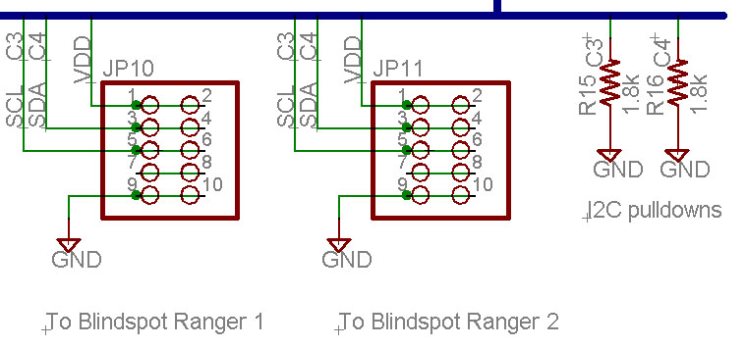
The ultrasonic sensors should be tested by placing a car at various distances from the sensor and displaying the distance read by the sensor on the LCD screen. The distance should be accurate to within a few inches. The indicator LED’s should light up when the vehicle is placed within the specified threshold distance. This should also be done while both vehicles are moving at speeds up to 60 mph.
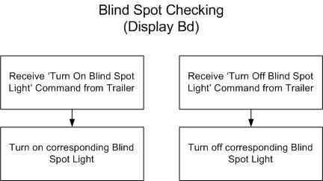
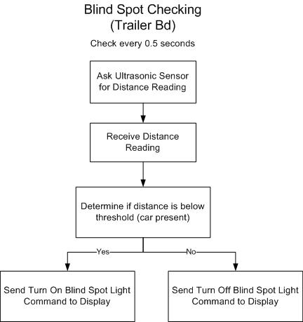
Software diagrams for Blind spot Checking:

Backup Ranging
The backup ranging function will be accomplished by using two IR distance sensors. These sensors return an analog voltage which will be A/D converted by the microcontroller into a distance measurement. The measurement will be transmitted to the display board, written to the LCD and if the distance is below the alarm threshold, an audible alarm will sound.
Partial Schematic: Backup Sensors
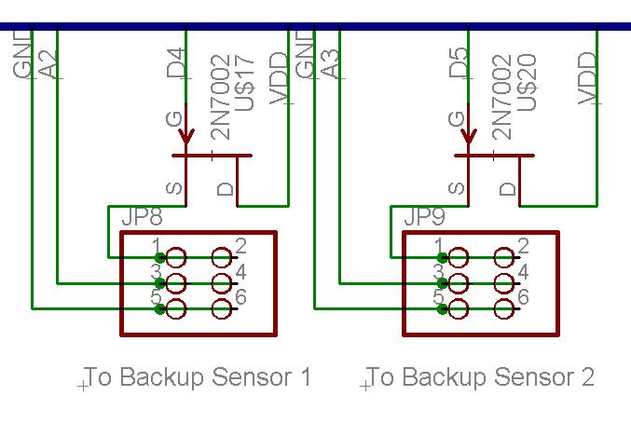
The IR proximity detection system should be tested by placing both black and white sheets of paper or poster board at various distances from the sensor. The distance displayed on the LCD screen should be within a few inches the actual measured distance. The functionality of the device should be verified between the distances of 30-150cm. Due to the fact that two IR devices will be used, both devices should be tested simultaneously at a distance of 5 ft. apart to verify that no cross talk takes place between the devices.

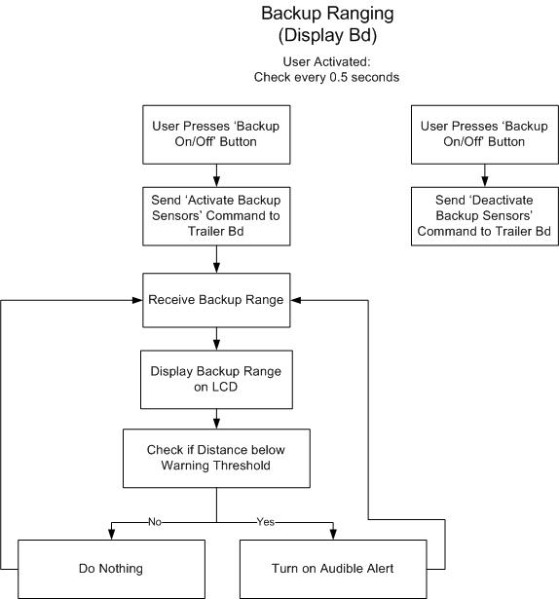
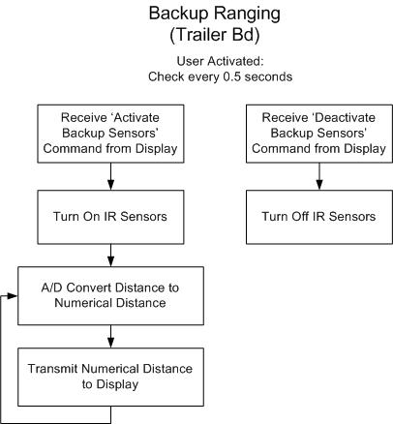
Software diagrams for backup ranging:

Brake/Blinker Light Burn-out Detection
To detect when a brake light or blinker has burned out, we will monitor both the current and the voltage on each brake/blinker line. When the voltage on one line goes high, we will measure the current through that line. If the current is above a certain threshold, the light is working and the indicator on the display will blink. If the current is below the threshold, the light is burned out; the corresponding indicator light will be turned on solid, and an error message will print to the LCD of the display unit.
Partial Schematic: Bulb Burnout Monitoring
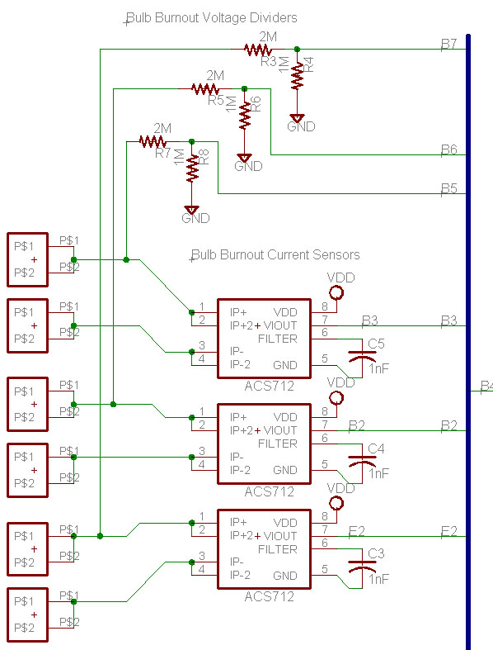
To test the burnout detectors, resistors should be placed across the sensing pins to simulate bulbs. A +12V DC signal should be applied to the left turn, right turn, and brake pins on the trailer board. A function should be written that A/D converts the outputs of the current sensors, and then turns an I/O pin high if the current is above a certain threshold. This pin will be externally monitored using the logic analyzer. The final function must include communicating with the display unit to notify the driver of a burned out bulb.

Software diagrams for rear light checking:
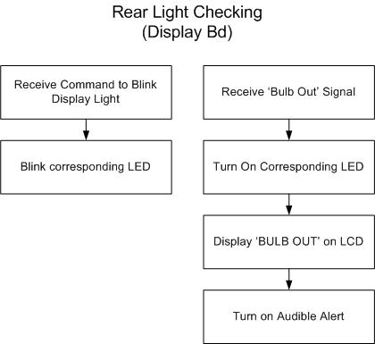
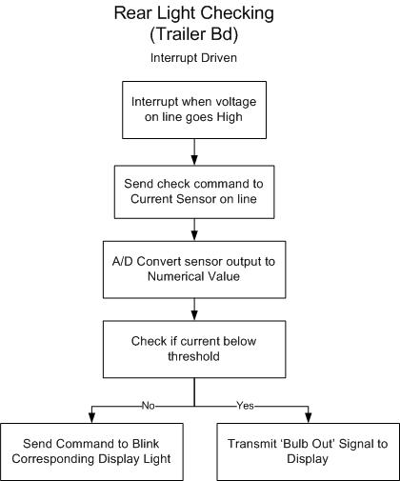

Inside Temperature Monitoring
The inside temperature monitoring will be accomplished with an IC chip manufactured by National Semiconductor. This chip outputs an analog voltage based upon the temperature. The microcontroller on the trailer board will A/D this signal, determine a value for the temperature in degrees and send this information to the display board. The display board will then print the temperature on the LCD screen, and alarm the user if the inside temperature is outside the defined alarm limits.
Partial Schematic: Indoor Temperature Sensor
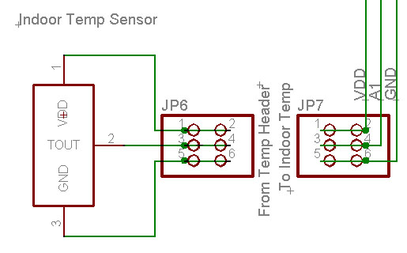
A function should be written to convert the output voltage of the temperature sensor to the actual physical temperature of the environment. This temp should be displayed on the LCD screen. A thermometer should then be used to measure the actual temperature and then compared to the temperature reading of the device. A hair dryer should then be used to artificially create more data points to compare. The measured sensor temperatures should be within +/-3 degrees of the actual temperature.
Software Diagrams for Inside Temperature Checking:
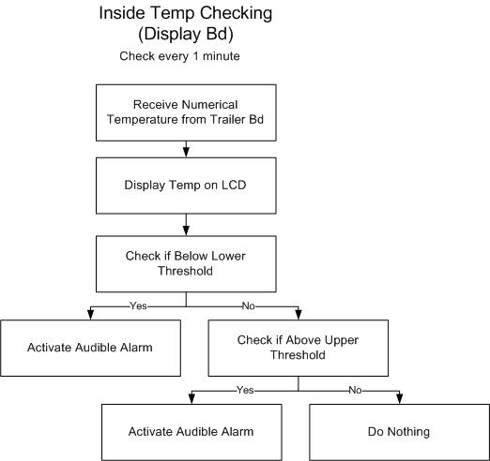
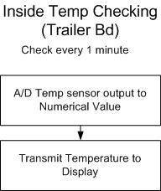

Outside Temperature Monitoring
The outside temperature monitoring is very similar to the inside temperature monitoring; the same chip will be used. The entire trailer board will be located outside the trailer, so this chip will be mounted and connected directly to the trailer pcb. The Display board will print this temperature to the LCD and light the ‘Icy Conditions’ indicators if the temperature is below 32°F.
Partial Schematic: Outdoor Temperature Sensor
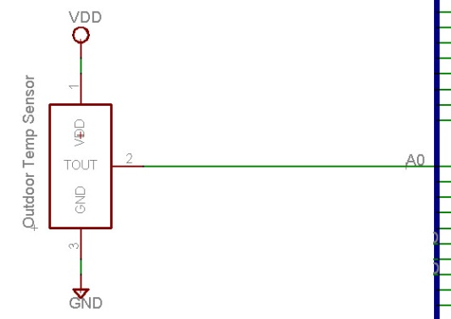
The same testing procedure as the inside temperature monitoring will be used. We must also cool the chip, possibly with ice, to ensure the ‘icy conditions’ indicators illuminates as planned.
Software diagrams for Outside temperature checking:
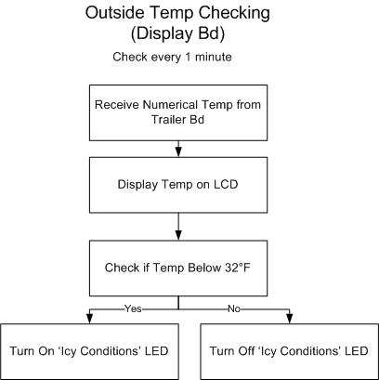
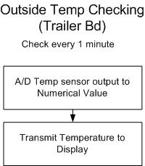

Door Monitoring
The monitoring of the trailer door will be accomplished with a magnetic sensor manufactured by Cherry. This device is a switch which is closed when a magnet is present and open when the magnet is taken away. The software will be interrupt driven and will alert the user when the door is ajar.
Partial Schematic: Magnetic Sensor
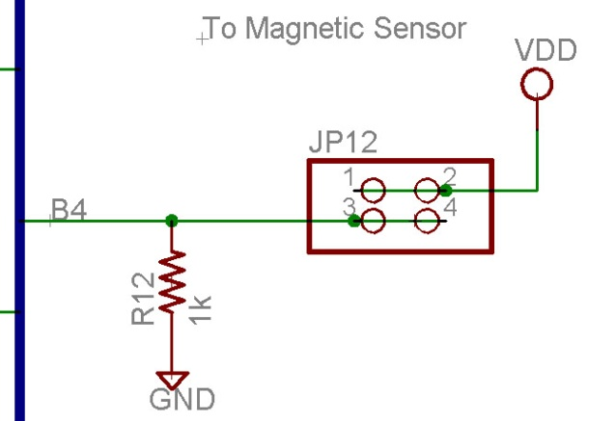
The door sensor should be tested by placing the magnet close to the sensing device, within the device’s spec; the door open alarm should be silent. The magnet should then be removed to verify that the door open alarm turns to its on state; this could be set to turn an I/O pin high and monitored with the logic analyzer. Once the alarm is activated the ‘silence alarm’ button should be pressed to verify that the alarm turns off and is reset.
Software diagrams for Door monitoring:
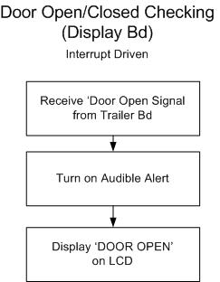
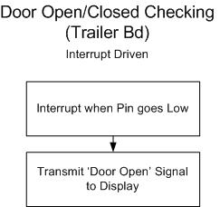

Preliminary Bill of Materials
A preliminary Bill of Materials is included in Appendix C. The final bill of materials will be turned in on Thursday, December 6, 2007.

Conclusion
During the course of writing this low level design document, we learned a great deal about our system. Specifically, we designed how each functional block will work, and how it will physically connect with the rest of the system. In addition, we now have a fairly detailed understanding of how our software will be organized and how it will function. We need to complete the bill of materials for ordering purposes, and we look forward to laying out the boards, getting the parts in and beginning to test our design!

References
- http://ww1.microchip.com/downloads/en/DeviceDoc/39626d.pdf
- http://www.national.com/ds/LM/LM2937.pdf
- http://www.national.com/ds/LM/LM2937-2.5.pdf
- http://rocky.digikey.com/WebLib/Agilent/Web%20Data/HLMP-331x,341x,351x.pdf
- http://www.nxp.com/acrobat_download/datasheets/2N7002_4.pdf
- http://www.maxstream.net/products/xbee-series-2/product-manual_XBee_Series2_OEM_RF-Modules_ZigBee.pdf
- http://www.national.com/ds/LM/LM45.pdf
- http://www.allegromicro.com/datafile/0712.pdf
- http://www.e-switch.com/pdf/PS1023.pdf
- http://www.crystalfontz.com/products/2402a/index.html#CFAH2402ATMIJP
- http://acroname.com/robotics/parts/R287-SRF02.html
- http://acroname.com/robotics/parts/R144-GP2Y0A02YK.html
- http://www.cherrycorp.com/english/sensors/pdf/MP2019_Series.pdf
- http://www.projectsunlimited.com/audioproducts/movieclips/products/drawings/SMI-1324-TW-5V-2-R.pdf

Appendix A: Display Board Schematic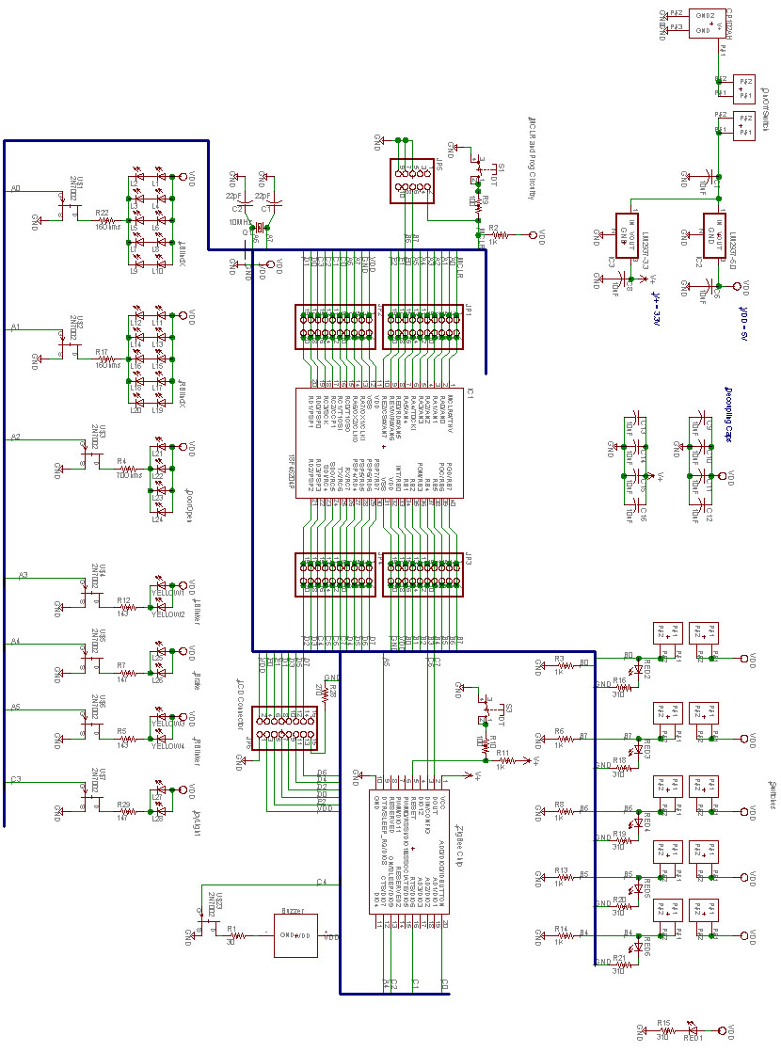
Appendix B: On-Trailer Board Schematic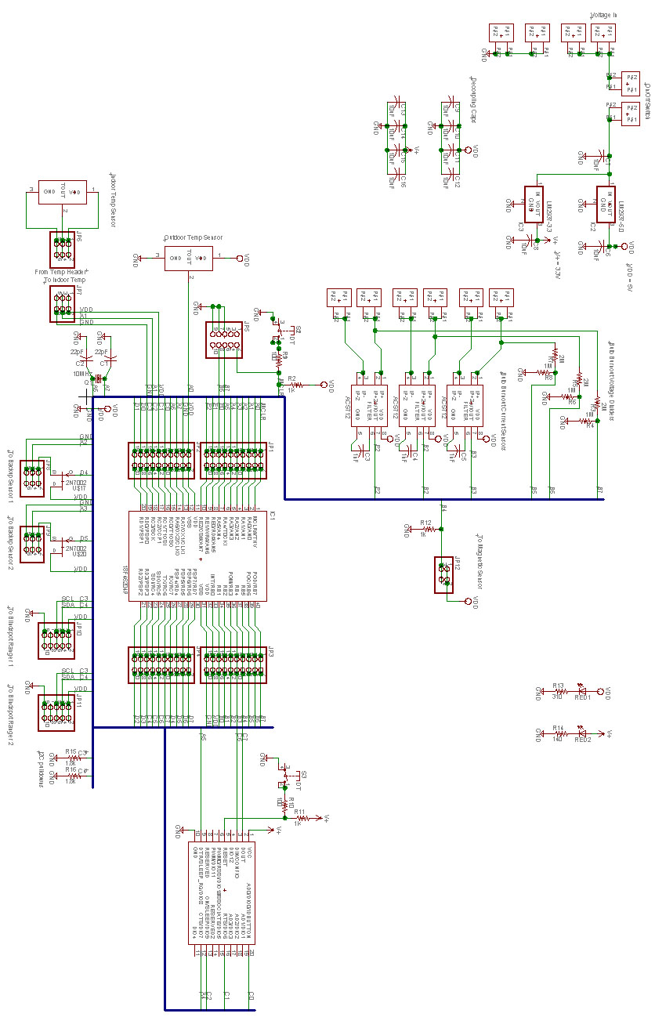

Average highway width is 12 ft: http://www.fhwa.dot.gov/ohim/hs01/hm33.htm

